About this document
We want to know what you think about the Advocacy Standard.
This document answers some questions you might have about the Standard.
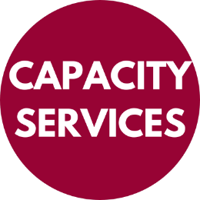 | This document is written for Capacity Services.  When you see the word ‘we’ it means Capacity Services.
This document is written in an easy to read way.
We call it Easy Read.
You might not know some words.
The first time we use those words they are blue.
We tell you what they mean.
They are also at the back of this document.
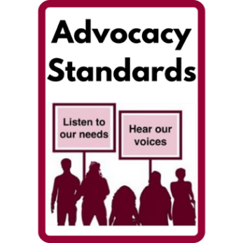 | Standards Australia is writing standard for advocacy.  We will call it ‘the Standard’ in this document.
Standards are like rules.
They tell people what is expected.
They make things safer better.
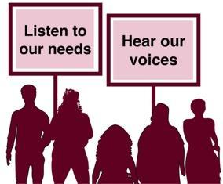 | Advocacy is telling other people:  - what you think  - what you need.  You can advocate or someone can help you.
 | Advocacy services are organisations that advocate with you.
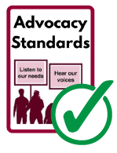 | Advocacy services will need to work in the ways the Standard say.
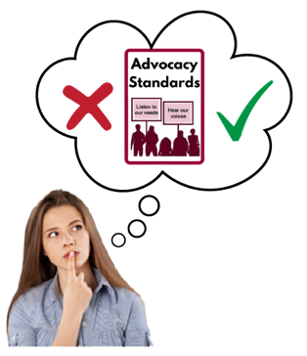 | We are helping Standards Australia find out what people think of the Standard.

8 FAQs
FAQs is short for Frequently Asked Questions.
These are the questions people ask us most.
We have answers for 8 questions.

Question 1: What is the Standard?
The Standard is also called AS 5391 Advocacy in Aged Care and Disability.
It is the first standard like this in the world.
The Standard will tell advocacy services how to:
- Know if they are doing a good job.
- See how they can do better.
Standards Australia is writing the Standard.

Question 2: What will the Standard do?
The Standard will tell advocacy services how to:
- Know if they are doing a good job
- See how they can do better.
The Standard is only for advocacy services.
 | The Standard says the minimum quality services can be.
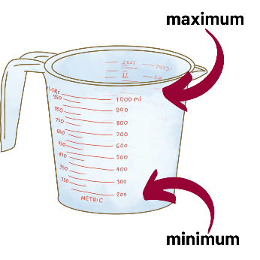 | Minimum means the least or the smallest amount.
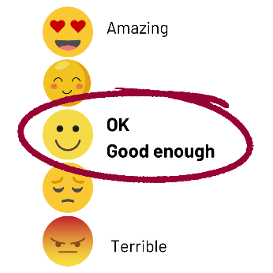 | Quality is how OK something is.  Minimum quality is good enough but not great.
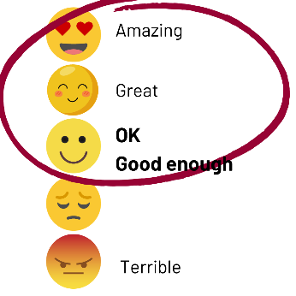 | Services must be the minimum quality but can be better.

Question 3: How will the Standard work?
Advocacy services can choose to work in the ways the Standard says.
At the moment advocacy services work in different ways:
- There are no standard just for advocacy services
- Disability advocacy services use the same standard as other types of services
- There is no standard for advocacy services for older people.

Question 4: Who is the Standard for?
The Standard is for advocacy services who:
- Advocate with people with disability
- Advocate with older people
Advocacy services can choose to work in the ways the Standard says.

Question 5: Whose idea was the Standard?
 | The idea to write the Standard came from:
OPAN
OPAN are the Older Persons Advocacy Network.
DANA
DANA are the Disability Advocacy Network Australia.
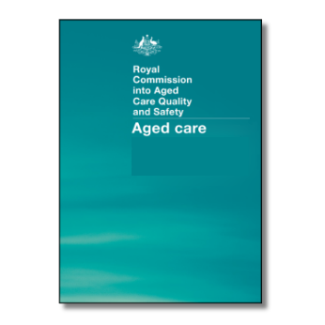 | A report on Aged Care made them decide that Australia needs the Standard.
 | Caring for older people is called Aged Care.
 | The Department of Health and Aged Care have helped pay for this work

Question 6: How was the Standard made?
Standards Australia is writing the Standard.
They are experts in many kinds of standards in Australia.
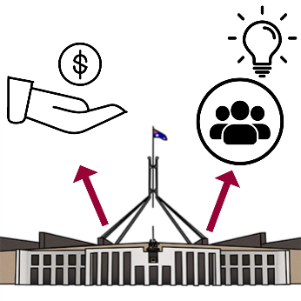 | Standards Australia have talked to many people including:  - People with disabilities  - Older people  - An expert writer.
A committee also helped to write the Standard.
A committee is a group who gives advice.
They met 8 times.
People on the committee were:
- People with disabilities
- Older people
- From governments
Governments run a country, state or area. They make decisions for people.
- People working with people with disability
- People working with older people
- From Advocacy services
- Experts
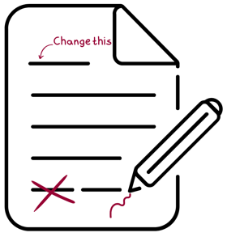 | They made changes to the Standard to make them better.

Question 7: Did people with lived experience help?
Having your own experience of something is called lived experience.
People with disabilities or older age have lived experience of those things.
A group of people with disability met 3 times.
A group of older people met 3 times.
They talked about what should be in the Standard.
They told the committee about their ideas.
Their ideas helped the committee.

Question 8: Who can comment on the Standard?
Anyone can tell Standards Australia what they think.
There are different ways to make comments.

Question 9: How can I comment on the Standard?
You can comment on the Standards Australia website.
Here is how.
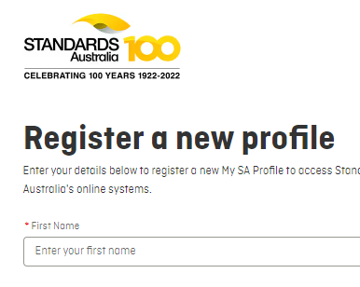 | - You will need to make an account and log in.  You can do that here.
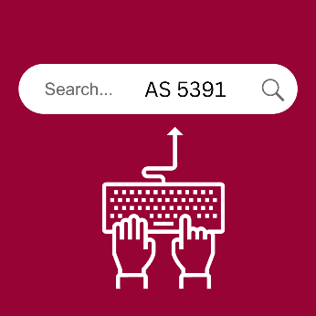 | - Then you can go to this link.  Or you can search for AS 5391.
 | - The website will tell you how to make your comment.

Question 10: Are there other ways to comment on the Standard?
You can tell Standards Australia what you think about the Standard at a forum.
Forums are a group of people talking about an issue.
Each person gets to have a say.
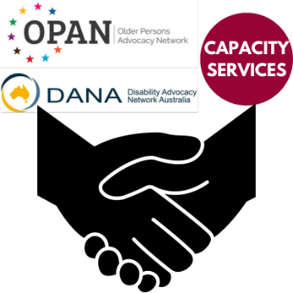 | We will hold forums with OPAN and DANA.  OPAN are the Older Persons Advocacy Network.  DANA are the Disability Advocacy Network Australia.
See our websites for more information about forums:
- OPAN.website
- DANA website
- Standards Australia website

Word List
Advocacy
Advocating is telling other people what you think and what you need.
You can advocate or someone can do it with you.
AS 5291 Advocacy in Aged Care and Disability
This is the full name of the Standard.
Committee
A committee is a group who gives advice.
DANA
DANA are the Disability Advocacy Network Australia.
Funding
Funding is money governments give to services to do their work.
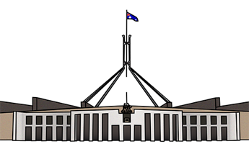 | Governments  Governments run a country, state or area. They make decisions for people.
Lived Experience
Having your own experience of disability or older age is lived experience.
Minimum
Minimum means the least or the smallest amount.
Quality
This is how OK something is.
Minimum quality is good enough but not great.
OPAN
OPAN are the Older Persons Advocacy Network.
Standards
Standards are like rules.
They tell people what is expected.
Easy Read document written by Jacqueline Gibb, Kathryn Carter, The Easy Read Toolbox for Capacity Services including images and text.

