Disability Royal Commission Response Consultation

Department of Social Services

A joint submission from Disability Representative Organisations

30 January 2024

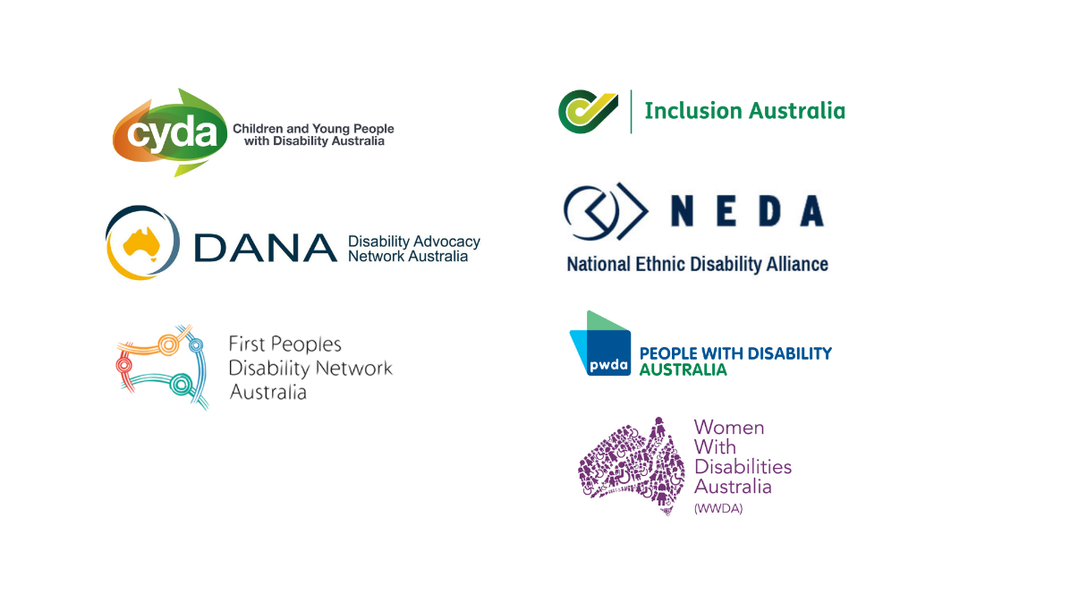
Table of Contents
About Us 3
Introduction 4
Recommendations 5
Leadership 6
Timing 7
Engagement 8
Resources 9

About Us
Disability Representative Organisations are funded by the Department of Social Services (DSS) to represent people with disability. The following organisations have endorsed this joint submission:
- Children and Young People with Disability Australia
- First Peoples Disability Network Australia
- Disability Advocacy Network Australia
- Inclusion Australia
- National Ethnic Disability Alliance
- People with Disability Australia
- Women with Disabilities Australia
This submission was prepared by Disability Advocacy Network Australia, in their role as the National Coordination Function for the Disability Representative Organisations program.

Introduction
People with disability, our families and supporters, and our organisations, fought for decades for action to stop the abuse so many of us experience from those around us. This fight culminated in the Royal Commission into Violence, Abuse, Neglect and Exploitation of People with Disability (Disability Royal Commission), held between 2019 and 2023.
The Disability Royal Commission provided a critical, once in a lifetime opportunity for Australia to understand the context, impact and extent to which violence, abuse, neglect and exploitation of people with disability occurred, and still occurs, in our society. The Disability Royal Commission’s final report is an opportunity to lay bare systemic ableism, discrimination and harm caused, and make concrete recommendations to effect change through a human rights framework, and significant reform, led by people with disability.
Many of the national Disability Representative Organisations (DROs) have come together to raise some key issues and concerns about the response to the Royal Commission’s final report. These include:
- Leadership
- Consultation
- Timing
- Resources

Co-signed:
- Skye Kakoschke-Moore, CEO, Children and Young People with Disability Australia
- Jeff Smith, CEO, Disability Advocacy Network Australia
- Damian Griffis, CEO, First Peoples Disability Network
- Catherine McAlpine, CEO, Inclusion Australia
- Dwayne Cranfield, CEO, National Ethnic Disability Alliance
- Sebastian Zagarella, CEO, People with Disability Australia
- Sophie Cusworth, Acting CEO, Women with Disabilities Australia

Recommendations
1: A Disability Reform Implementation Council is established urgently to oversee Disability Royal Commission and NDIS Review changes, led by people with disability and our organisations.
2: That sufficient time is allowed for responses to the Disability Royal Commission to ensure people with disability can be heard.
3: That DSS consult with DROs about, and then release their planned program of engagement with people with disability and our organisations as soon as possible.
4: That DROs receive additional systemic advocacy funding for the next five years to engage and lead on reforms from the Disability Royal Commission.

Leadership
People with disability, our families and supporters and our organisations have campaigned for decades to stop people hurting us, including the long fight for a Disability Royal Commission.
During the four and a half years of the Disability Royal Commission, we led calls for change, supported thousands of people with disability and their families to give evidence, contributed time, expertise, submissions, personal evidence and much more. We attended public hearings online and in-person, and made multiple appearances as witnesses to give evidence on relevant issues.
We met regularly with Royal Commission staff, promoted public hearings including through live-Tweeting, published stories from people with disability, and provided a wide range of evidence and rights-based solutions to end the violence.
In their final report, the Disability Royal Commission acknowledged this work, saying that this had ‘been indispensable in framing recommendations designed to achieve a more inclusive society that supports that independence of people with disability and their rights to live free from violence, abuse neglect and exploitation.’
However, since the Disability Royal Commission final report was handed down, we have had no formal role in working with the Commonwealth to work through the recommendations or to decide on priorities for action.
Our organisations have called for the establishment of a Disability Reform Implementation Council, led by people with disability and our organisations, to oversee the changes flowing from the Disability Royal Commission and the NDIS Review, many of which overlap.
The Council must have people with disability, our families and organisations at the table to share in decision-making. This is in line with Australia’s Disability Strategy. We believe that all levels of government must be represented, along with key departments and agencies.
The Council would report directly to National Cabinet and have working groups specialising in key reform areas including education, employment, housing, health and aged care. In addition, there will be working groups to address issues for different communities of people with disability.
It would be a particular focus on ensuring the work of the Council is underpinned by the priority reforms of the National Agreement of Closing the Gap, already agreed to by all governments, in recognition of the continued marginalisation of First Nations people with disability.
The implementation of reforms from the Disability Royal Commission can only be effective in stopping the violence so many of us live through if we are leading that implementation.

Recommendation 1: A Disability Reform Implementation Council is established urgently to oversee Disability Royal Commission and NDIS Review changes, led by people with disability and our organisations.

Timing
Our organisations have significant concerns about the timing of this consultation, the capacity to engage with people with disability, particularly those with significant barriers to having their voices heard, and our sustainability of staff and organisations to respond to the overwhelming number of requests for engagement and consultation.
Last year was an exceptionally busy year for our organisations, in responding to the increasing amount of systemic advocacy work, the NDIS Review engagement work and the two large reform reports from the Disability Royal Commission and the NDIS Review. As such, many of our staff have taken leave over December and January to address overwork and burnout, and in preparation for the year ahead. There has been little to no time or capacity to engage with people with disability to discuss priorities, or to respond in depth to this consultation.
We urge DSS and the Commonwealth to allow sufficient time to engage with people with disability about these reforms.

Recommendation 2: That sufficient time is allowed for responses to the Disability Royal Commission to ensure people with disability can be heard.

Engagement
Our organisations worked over the last five years to contribute enormously to the Disability Royal Commission, giving evidence at public hearings, preparing substantial submissions, and supporting many people with disability to have their say. Our priorities have been clear, including through these joint statements and campaigns to and about the Disability Royal Commission.
- End Segregation joint statement
- DRO Joint statement on identified gaps
- We Need More Time – campaign to extend the Royal Commission
- Make It Safe to Speak – campaign to protect confidentiality
In addition, our organisations engaged deeply with the functions of the Disability Royal Commission, through joint letters to the Chair and work with the engagement, policy, counselling, accessibility, communications and legal teams.
Collectively, we have a deep knowledge about the Disability Royal Commission and contributed very significantly to the work of the Commission.
As such, our priorities are on the record, including in the final report and the recommendations. Given the breadth and depth of our engagement, asking our organisations to participate in a consultation without acknowledging our unique role in the Disability Royal Commission has been challenging.
As stated earlier, people with disability must lead the responses to the Disability Royal Commission, including via our representative organisations. We are the people who have experience of violence, abuse, neglect and exploitation, and have to be at the forefront of measures to stop this happening to us.
The Disability Reform Implementation Council would be an excellent step forward in recognising the role of DROs in implementing changes, as will a detailed, transparent program of reform as soon as possible.

Recommendation 3: That DSS consult with DROs about, and then release their planned program of engagement with people with disability and our organisations as soon as possible.

Resources
To manage the large increase in workload for DROs, including to engage fully with people with disability and our families and supporters, our organisations need a significant uplift in resources.
For the duration of the Disability Royal Commission, in recognition of the particularly intense work that DROs were doing, we received additional systemic advocacy funding. However, despite the likelihood of very significant additional engagement and systemic advocacy work, over and above our current work, we have not received any indication that further resources will be provided to our organisations.
DROs needs additional resources in order to engage staff, develop consultation mechanisms and deliver on this complex, cross-government liaison and co-design.
Many of our organisations work with significantly marginalised people with disability, including from population groups that have many barriers to having their voices heard.
In addition, given the length of time for these reforms to be completed, this funding should be for the entirety of that implementation.
Already, our organisations have lost very experienced staff due to the reduction in resources, and the ongoing insecurity of funding caused by the current grant rounds for DRO and Information, Linkages and Capacity Building funding. If we are to attract and retain the skilled and experience staff, particularly those with disability, to do the work flowing from the Disability Royal Commission, we urgently need clarity about resourcing levels.
Other significant reforms, such as the National Agreement on Closing the Gap and the response to the Aged Care Royal Commission, have recognised the need to engage with and resource the communities affected to share in decision making about priorities.
These reforms will not succeed without the expertise and engagement of people with disability.

Recommendation 4: That DROs receive additional systemic advocacy funding for the next five years to engage and lead on reforms from the Disability Royal Commission.

Executive Summary, Our vision for an inclusive Australia and Recommendations, Disability Royal Commission, piii

